**UNIT 4**

**FOOD AND DRINK**

**A. VOCABULARY:**

**Exercise 1: Put the words in the correct categories to complete the table.**

|  |
| --- |
| *milkshake yogurt cabbage basil butter cheese lamb*  *salt and pepper juice rice beef lemonade chill bread*  *chicken onion carrot salad* |

|  |  |  |  |  |
| --- | --- | --- | --- | --- |
| **dairy products**  **(=foods made from milk)** |  | **herbs and spices**  **(=food that gives strong flavors to other food)** |  | **meat** |
| Cheese |  | salt and pepper |  | Chicken |
| yogurt |  | onion |  | Lamb |
| Butter |  | chill |  | Beef |

|  |  |  |  |  |
| --- | --- | --- | --- | --- |
| **side dishes**  **(food that you eat along with the main course)** |  | **soft drinks** |  | **vegetables** |
| rice |  | juice |  | Carrot |
| bread |  | lemonade |  | basil |
| salad |  | Milkshake |  | cabbage |

**Exercise 2: Complete the definitions. Use the sentence endings in the box.**

|  |
| --- |
| *you cook it at a temperature below boiling. you cook it for too long and it goes black.*  *you cook it in an oven. you cook it in hot oil or fat. you cook it under a very hot place.*  *you cook them in an oven, using a little oil or fat.*  *you cook them in water that is boiling (= very hot). you cut it into long, thin pieces.*    *you cut them into pieces with knife. you put it on plates so that people can eat it.* |

1. When you chop vegetables,  *you cook it in hot oil or fat.*
2. When you boil potatoes, *you cook it at a temperature below boiling*
3. When you fry meat, _ *you cook them in an oven, using a little oil or fat*
4. When you simmer soup, *you cook them in water that is boiling (= very hot)*
5. When you burn toast, *you cook it for too long and it goes black*
6. When you slice cheese, *you put it on plates so that people can eat it*
7. When you bake a cake,  *you cook it in an oven.*
8. When you roast potatoes, *you cook it under a very hot place.*
9. When you serve a meal, *you cut it into long, thin pieces.*
10. When you serve a meal, *you cut them into pieces with knife*

**Exercise 3: Complete the descriptions. Use the words in the box**.

|  |
| --- |
| crockery cutlery frying pan kettle napkin saucepan scales  serving dish tin opener utensils |

1. A _ frying pan __ is a wide pan that you use to fry food in.
2. The general name for knives, forks and spoons is ___ cutlery __ .
3. A __ napkin _ is a small piece of cloth or paper used while you’re eating to protect your clothes or clean your mouth or fingers.
4. The general name for cups, plates, bowls, etc. is __crockery__ .
5. A _tin opener_ is something that you use to open tins of food.
6. A _saucepan__ is a deep pan that you use for cooking vegetables or pasta in water.
7. You can use _scales_ to weigh ingredients.
8. A _serving dish_ is a bowl where you keep food before you put it onto plates.
9. The general name for wooden spoons, kitchen knives and other things that help you cook is kitchen ___utensils___ .
10. You can use a __kettle__ to boil water.

**Exercise 4: Complete the sentences. Use the adjectives in the box.**

|  |
| --- |
| bland delicious disgusting hot mild raw salty  savory spicy sweet |

1. I love ___ hot__________ food. It’s hot and has lots of strong flavors.
2. I prefer ______sweet_________ food. It still tastes good, but it’s not hot and the flavors aren’t very strong.
3. _mild________ pies, like apple pie, are popular in many countries.
4. _savory________ pies, like meat pie, are also popular in some countries.
5. I don’t like _______ spicy ______ chilli. It’s too strong for me.
6. This meal is delicious________ . It tastes really nice.
7. I don’t like mashed potato. It’s so _____bland__ and doesn’t really taste of anything.
8. These carrots are very ___salty_____ . There’s too much salt on them.
9. This meat is still _____raw__________ ! Please cook it a bit longer.
10. The meal was _____disgusting______ . It tasted horrible!

**Exercise 5: Choose the best words to complete the conversation.**

**A:** Come in! Dinner’s nearly *cooking/made/****ready*** .

**B:** Oh, great. It ***feels****/smells/tastes* lovely. What is it?

**A:** It’s Jollof rice. It’s a traditional ***dish****/meal/plate* from West Africa.

**B:** Oh, right. So what’s it made *of/****on****/to* ?

**A:** Well, the main ***course****/ingredient/recipe* is rice.

**B:** OK. What else is *from/****in****/with* it?

**A:** Well, it also ***contains****/ holds/involves* fried onions and tomatoes. Plus lots of spices like chilli and pepper to give it a strong *appetite/color****/flavor*** *.* Would you like to *fry/test/****try*** it?

**B:** Yes, please. Oh, that is nice. It *looks****/tastes****/seems* delicious.

**B. GRAMMAR:**

**Exercise 1: Read the information. Then read the sentences and choose the correct answers.**

|  |
| --- |
| **Countable nouns:**  Things that you can count, e.g. *one book*, *two books*; *one person*, *two people*.  **Uncountable nouns:**  Things that we don’t normally count, e.g. *water*, *fun*. |

1. *I went to the shop and bought two ice creams, one for me and one for you.*

In this sentence, ‘*ice cream*’ is

* **countable**
* uncountable

1. *For dessert, we’ve got ice cream.*

In this sentence, ‘*ice cream*’ is

* countable
* **uncountable**

1. *In my family, we often have pizza for dinner. It’s our favorite meal.*

In this sentence, ‘*pizza*’ is

* countable
* **uncountable**

1. *I ordered a takeaway pizza, but when it arrived, it was really small.*

In this sentence, ‘*pizza*’ is

* **countable**
* uncountable

1. *Would you like a chocolate?*

In this sentence, ‘*chocolate*’ is

* **countable**
* uncountable

1. *I never eat chocolate. It’s too sweet for me.*

In this sentence, ‘*chocolate*’ is

* countable
* **uncountable**

1. *Could we have three coffees, please?*

In this sentence, ‘*coffee*’ is

* **countable**
* uncountable

1. *Do you like coffee?*

In this sentence, ‘*coffee*’ is

* countable
* **uncountable**

**Exercise 2: Read the information. Then choose the correct words to complete the sentences.**

|  |
| --- |
| We use *much* with singular uncountable nouns and *many* with plural nouns |

1. How ***many****/much* meals do you eat every day?
2. We haven’t got *many/****much*** bread. Can you buy some?
3. There wasn’t *many/****much*** food at the party, so i’m still hungry!
4. You eat too ***many****/much* sweets. They’re bad for your teeth.
5. Do you eat *many/****much*** fruit?
6. How *many/****much*** rice do you want? A lot or just a little?
7. You didn’t cook ***many****/much* peas. Are you sure there are enough for all of us?
8. I don’t want too *many/****much*** spaghetti. I’m not really hungry.
9. There’s too *many/****much*** butter on that toast! It’s not healthy.
10. I don’t eat ***many****/much* eggs. I don’t really like them.

**Exercise 3: Choose the correct words to complete the text.**

For breakfast, I usually have *a/any/****some*** toast and jam. I don’t put *a/any/****some*** butter on my toast. I usually just drink ***a****/any/some* cup of tea with my breakfast. I don’t put *a/****any****/some*  sugar in my tea – I don’t like sweet drinks. At the weekend, I often have ***a****/any/some* egg for breakfast. Then, at about 11 o’clock, I usually have *a/any****/some*** coffee break. I eat *a/any/****some*** biscuits – just two or three. Then for lunch, I usually have ***a****/any/some* sandwich. I also eat ***a****/any/some* fruit, like an apple or an orange. I never eat *a/****any****/some* crisps – they’re really unhealthy.

**Exercise 4: Complete the description of how to make scrambled eggs. Use *a*, *the*, *some* or *any*.**

1. You will need __some_ butter, two or three eggs and __a_ large frying pan.
2. First of all, break _____some______ eggs into _____a______ bowl.
3. Make sure there aren’t ______any______ pieces of eggshell in ____a_________ bowl.
4. Mix _____some_______ eggs with _______a_____ fork .
5. Now melt ______some___ butter in _____the_______ frying pan.
6. When ____the________ butter has melted, pour ___the___ eggs into the frying pan.
7. Use _____a__ wooden spoon to stir the eggs in _____the______ pan .
8. When it’s nearly ready, add ____some_____ salt and pepper to ______the___ eggs.
9. Keep mixing ______the______ eggs with ______a_____ wooden spoon.
10. When it’s ready, serve _____the___ scrambled eggs with ______some__ toast.

**Exercise 5: Choose the correct answers to complete the sentences.**

1. I eat *a few/ a little/* ***a lot of*** cheese – too much, really, but I love it.
2. I made ***a few****/ a little/ a lot of* sandwiches, but our visitors still ate every single one!
3. When I was younger, I ate a lot of chocolate, but I eat ***fewer****/less/ more* chocolate now – I'm trying to be healthier.
4. We prepared enough food for ten people, but there were a lot *fewer/less/* ***more*** people than that at the party. It was really crowded!
5. The extra-large pizza is perfect for four or more people. For ***fewer****/less/ more* people, we recommend a normal pizza.
6. It’s better to cook your own food than to buy fast food. Cooking usually takes *fewer/less/* ***more*** time, but it’s much healthier.
7. A: So who did you invite for dinner?  
   B: Just ***a few****/ a little/ a lot of* people – only three.
8. A: Do you want some milk or sugar in your coffee?  
   B: Just *a few****/ a little****/ a lot of* milk, please. Not too much.
9. A: How much time do you spend cooking every day?  
   B: *A few/ A little/* ***A lot***! At least three hours every day.

**C. READING:**

**Exercise 1: In this unit, you will answer IELTS Reading matching information questions and read a text called ‘How technology has changed the way we communicate’.**

**What do you know about the development of the telephone? Match the decades with the correct photos.**

|  |
| --- |
| 1920s 2000s 1970s 2010s 1980s |

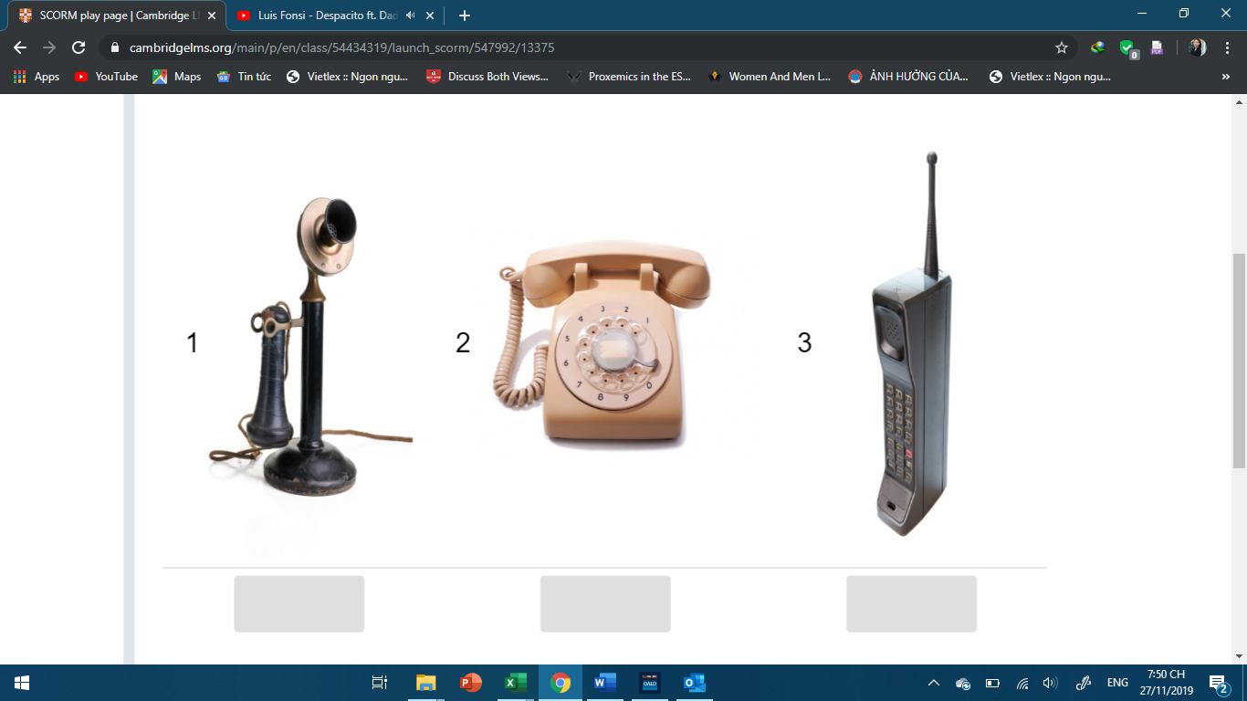

1980

1970

1920

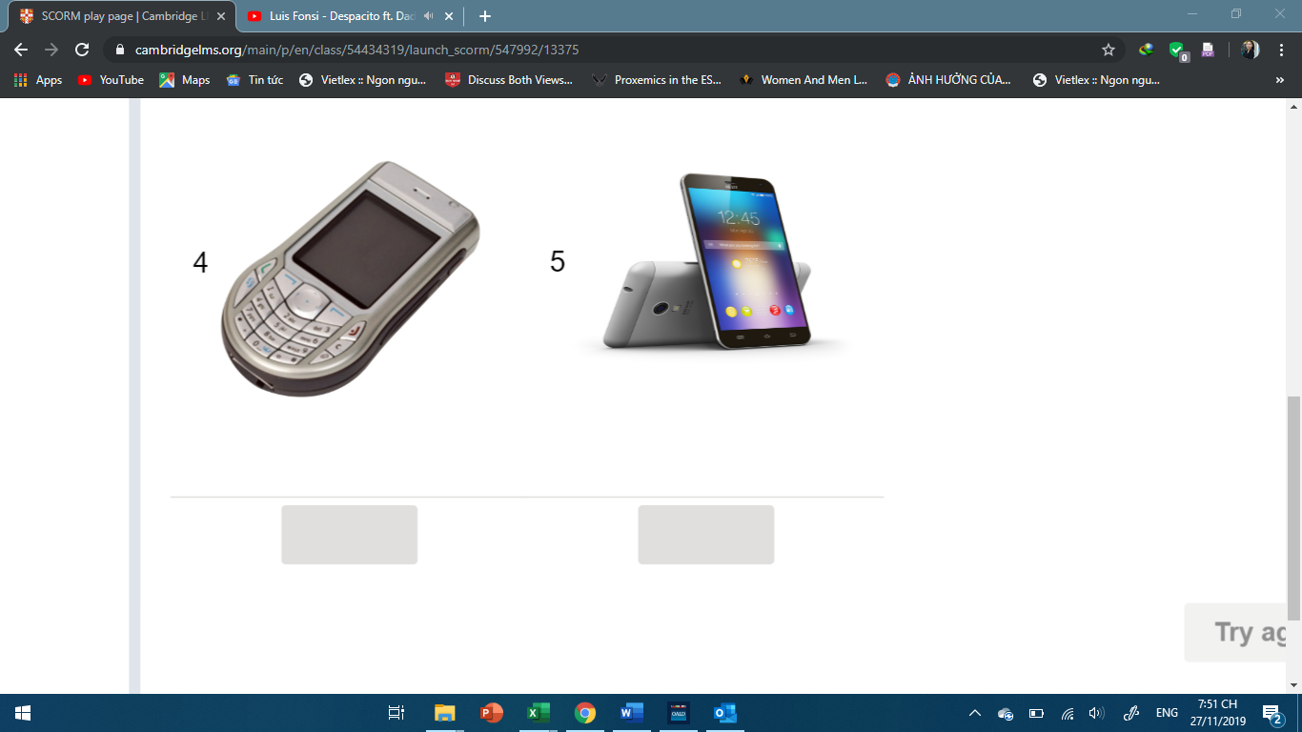

2000

2010

**Exercise 2: What words and phrases do you already know for describing communication? Match the words and phrases with the definitions.**

|  |
| --- |
| formal interaction online forum relationship social media  social network to get in touch to keep in touch to respond update |

1. to begin communicating with someone, for example, by email or telephone: _**to get in touch**
2. to continue communicating with someone, for example, by email or telephone: **To keep in touch**___
3. new information on a particular topic: __**update**__
4. the different groups of people that you know: ___**Social media**_
5. websites and computer programs that allow people to communicate on the internet:_**Social network**___
6. a time when two or more people communicate with or react to each other: _**interaction**__
7. to say or do something in reply to something that has been said or done earlier: **To Respond**
8. describes language, clothes and behavior which is used in important and serious events, for example a job interview: __**formal**_
9. a place on the internet where people can leave messages or discuss particular topics: _**Online Forum**_
10. the way in which two or more people feel and behave towards each other: _**Relationship**_

**Exercise 3:** **Read the information. Then match the phrases describing types of information with the words in bold in the statements.**

|  |  |
| --- | --- |
| In an IELTS Reading matching information task, you will read a text and some statements about it.  It is important to understand what types of information the statements need you to find. The types of information might be:   * an **example** of / some **examples** of … * a **comparison** between … * a **description** of … * a **reference** to … * a **prediction** about … | |
|  | a comparison between a description of a prediction about a reference to  an example of | |

1. Young students use Instagram **far more than** they use SnapChat. _**a comparison between**_
2. Digital devices **will probably replace** books in all UK schools by 2030. _**a prediction about**__________
3. The new phone has **a great camera** and **a clever feature** which makes apps easy to use. _**a description of**____________
4. **The first email message** was sent in 1971. _**a reference to**___________________
5. There are many reasons why I stopped using social media, **such as** the huge amount of time it took up. __**an example of**____

**Exercise 4:** **Read this paragraph from the text. What information does it contain? Choose the correct answer.**

**How technology has changed the way we communicate**

**Paragraph A**

It’s often impossible for teenagers to imagine that in the past we all had to make our social arrangements either face-to-face or using a telephone landline. Just 20 years ago, trying to organize a visit to the cinema meant that you had to call your friends at least a day in advance and hope they’d be home when you rang. If someone didn’t turn up, you could try to call them from a public telephone box. If their parents were home, you could leave a message, but your plans for the evening would probably be ruined.

 The information in **Paragraph A** is:

* a comparison between the advantages of old and new technology.
* **a description of the difficulties people used to have before they had mobile phones.**
* a reference to the way technology can make relationships better or worse.

**Exercise 5: Read the information. Then match the types of information with the sentences.**

|  |
| --- |
| When reading an IELTS Reading text, it is important to think about what type of information it covers. Other types of information could be:   * a **reason** for ... * **details** of ... * a **description** of ... * a **suggestion**.. |

|  |
| --- |
| *a description of a reason for a suggestion details of* |

1. Perhaps we should focus more on face-to-face communication than digital communication? __***a suggestion***___________________
2. Fewer people are sending letters by post because stamps are very expensive nowadays. ______***a reason for*** __________________
3. Mervyn's YouTube channel had a huge number of followers. His videos were about his daily life in New York and where people could go to find the best R’n’B music in Manhattan. _____________***a description of*** ___________
4. 75% of teens in the 12–17 age group own mobile phones. Every month, girls send out approximately 3,952 messages, and boys send about 2,815. ___***details of*** _____

**Exercise 6: Read the next paragraph. Then match the information statements (A–D) with the numbered parts of the paragraph (1–3). There is one information statement that you do not need**.

**Paragraph B**

Nowadays, getting in touch is a lot easier. Almost every aspect of human communication has changed: we have email, text, Skype, Facebook and Instagram, and we are certainly busy using them to build and maintain our relationships. According to recent reports, the top social networks now each have more than a billion monthly active users. And keeping in touch isn’t just something we do in class or at work any more: we continue to communicate with friends, strangers, family and colleagues **(1) while we’re on the train, in the living room and at the dinner table, for instance.** One recent British study indicated that **(2) 79% of teens even put their phone under their pillow so they can keep up-to-date with whatever is happening on social media day and night, and not miss out on updates.** As for adults, a recent survey showed that **(3) they now spend 20 to 28 hours a week on social media and have on average 275 personal connections. However, in contrast, only 11% of these same people actually meet their social connections** in an actual physical environment on a regular basis.

|  |
| --- |
| *A. a comparison between the time spent online with friends and time spent in real places*  *B. some examples of typical locations in which digital technology may be found*  *C. the reason why some young people feel the need to keep a digital device with them at all times*  *D. the suggestion that adults could learn about digital communication from their children* |

|  |  |
| --- | --- |
| 1. | B:1- **while we’re on the train, in the living room and at the dinner table, for instance** |
| 2. | C: 2- **79% of teens even put their phone under their pillow so they can keep up-to-date with whatever is happening on social media day and night, and not miss out on updates.** |
| 3. | A:1 - **They now spend 20 to 28 hours a week on social media and have on average 275 personal connections. However, in contrast, only 11% of these same people actually meet their social connections** |

**Exercise 7: Read the next paragraph. Then complete the matching information statements for the numbered parts of the paragraph. Use the words in the box.**

**Paragraph C**

Email is now one of the most common means of communication. At the moment, over 100 billion emails are sent and received per day for business purposes. (1) **This trend is expected to continue, and business email will account for over 132 billion emails sent and received per day two years from now**. The number of letters which are sent through the post, however, has decreased dramatically. (2) **A consequence of this is that many town and village post offices have closed**. **These were once places where a great deal of social interaction used to take place between local people. Now it is no longer possible for neighbors or workers in the area to meet up with each other like this, and older people in particular are often unhappy about this development.** But certainly the advantages of email cannot be ignored: in the past, the post would only be delivered once or twice a day. If a letter was sent to an overseas destination, it could take months. Without doubt, email has made it easier to do business.

|  |
| --- |
| *a description a prediction community form of communication* |

* 1. __ *a description* _ of how a particular __ *form of communication* ___
  2. _ *a prediction* ___ of how the loss of a public service has affected the __ *community* ___

**Exercise 8: Quickly skim read the next paragraphs. Then do the exercise**.

**Paragraph D**

However, there are several downsides to this form of technology. Firstly, no one would disagree that email puts pressure on people to respond immediately as soon as they find a new message in their inbox. A recent French report says that anxiety and general tiredness has risen dramatically amongst office workers, largely because they carry their digital devices with them, feeling obliged to constantly check for new mail from clients. A further problem is how to write an email, especially when communicating with people we don’t know well. In the past, everyone knew that it was ‘correct’ to begin a letter ‘Dear Sir/Madam’ and end with ‘Yours faithfully’. Nowadays, these phrases often feel too formal. No one wants to give the wrong impression when writing an email, but without ‘rules’, this can easily happen.

**Paragraph E**

Another significant impact technology has had on methods of communication is in the field of education. Traditionally, if someone wanted to take a higher education course, they would have to travel to attend lessons on a university campus. Nowadays, it is possible to take a range of courses through distance learning, and the number of these is likely to rise in the next few years. What is the appeal of studying this way? Many online courses encourage students to take part in online forums and post comments about their learning experiences, reading assignments and projects. They must also comment on their classmates’ posts. In one way, this approach certainly appears to encourage communication.

**Paragraph F**

However, some surveys have found the opposite to be true. Because online students are physically separated, and indeed may never have met, they do not have the opportunity to build a good relationship. Students who come to campus regularly have the chance to get to know and support each other, and feel part of a community, so when they are asked to comment on the other person’s work, they can do this in ways they know the other person will appreciate. For example, some students prefer their peers to be direct in their criticism, whereas others might prefer a more sensitive approach. But when students are asked to comment on the work or opinions of people they have never met, they are often reluctant to do so. Interestingly, one of the main reasons why people give up studying on their online courses is that they miss the face-to-face interaction with others. Certainly technology has made our lives more ‘convenient’ but perhaps also more complicated. There are many questions still to be answered about how we can and should use our modern digital tools to enable effective communication, an evolutionary skill that has been centuries in development.

**Match the paragraphs with the general topics.**

1. the advantages of studying online

* D
* **E**
* F

1. problems that occur at work and in formal situations because of digital communication

* **D**
* E
* F

1. the disadvantages of studying online

* D
* E
* **F**

**Exercise 9: Read paragraphs D-F again, this time more carefully. Which paragraph contains the following information? You may use any letter more than once**.

* 1. a reason why some learners do not complete an academic program
* D
* E
* **F**
  1. a reason for an increase in levels of stress in employees
* **D**
* E
* F
  1. a prediction about the way that an academic service might develop in the future
* D
* E
* **F**
  1. an example of a traditional practice in writing that people used to use more often
* D
* **E**
* F
  1. a comparison between the ways that different people like to be given feedback on their work
* D
* **E**
* F

**EXAM PRACTICE:**

**Passage 1:**

|  |
| --- |
| **GRAPHIC NOVELS**  *People who think graphic novels are just comics with a different name should think again*  **A**. Graphic novels, as the name suggests, are books written and illustrated in the style of a comic book. The term graphic novel was first used in 1978 by author and artist Will Eisner to distinguish a comic novel he had written and illustrated from newspaper comic strips. He described graphic novels as consisting of 'sequential art' — a series of illustrations which, when viewed in order, tell a story.  **B**. Although today's graphic novels are a recent phenomenon, this basic way of telling stories has been used in various forms for centuries. Early cave drawings, hieroglyphics and medieval tapestries are examples of this. The term graphic novel is now generally used to describe any book in a comic format that resembles a novel in length and narrative development.  **C**. Many adults feel that graphic novels are not the type of reading material that will help young people become good readers. They believe that graphic novels are somehow a bad influence that prevent 'real' reading. In other words, they think that they are not 'real' books.  **D**. However, many quality graphic novels are now being seen as a method of storytelling on the same level as novels, films or audio books. From originally appealing to a small following of enthusiasts, they are now being accepted by librarians and teachers as proper literature for children and young adults. The main advantages are that they promote literacy, and attract and motivate young people to read.  **E**. How do we know this? In the last few years, teachers and school libraries have reported outstanding success getting children to read with graphic novels. Many have mentioned the motivational factor of the graphic novel. This has been especially true with children who are usually reluctant to read, especially boys. The colorful pictures attract them, and then encourage them to find out what the story is about. Providing young people of all abilities with a wide range of reading materials, including graphic novels, can help them become lifelong readers.  **F**. Furthermore, one of the main benefits of a graphic novel is that it can help students who are learning a foreign language, and who are having problems improving their reading skills. This is because the pictures provide clues to the meaning of the words. Language learners are therefore more motivated by graphic novels, and will acquire new vocabulary more quickly.  **G**. Many teachers have reported great success when they have used graphic novels with their students, especially in the areas of English, social studies and art. They have discovered that, just like traditional forms of literature, they can be useful tools for helping students examine aspects of history, science, literature and art.  **H**. The idea that graphic novels are too simple to be regarded as serious reading is no longer valid. The excellent graphic novels available today demand many of the same skills that are needed to understand traditional works of fiction. Often they actually contain more sophisticated vocabulary than traditional books. Reading them can help students develop the skills that are necessary to read more challenging works. |

**Questions 1 -7:**

**The Reading passage has eight paragraphs, A-H.  
Which paragraph contains the following information?**  
*Write the correct letter, A-H.*  
NB *You may use any letter more than once.*  
   
*1.  people with negative attitudes towards graphic novels  __C____  
2.  a variety of school subjects where graphic novels can play an important role  _F__  
3.  why a graphic novel's visual element speeds up learning  __G_____  
4. a modern definition of graphic novels  __A___  
5.  graphic novels are as good as any other method of telling a story  __D__  
6.  graphic novels sometimes use advanced words   __F_____  
7.  the historical use of pictures as a method of storytelling  __E__*

**Passage 2:**

|  |
| --- |
| **The rain makers**  *Science and technology work with nature to bring rain when and where it is needed.*  **A.** Wheat farmer Gang Liu is a worried man. The annual rains have not arrived, and there is a danger that unless there is substantial rainfall soon, his annual wheat crop will fail. As he looks anxiously at the clouds which promise rain but are failing to deliver it, there is a sudden loud roar, and from fields for miles around, hundreds of small rockets are fired into the clouds. Within twenty minutes, the farms around the eastern Chinese city of  Luohe are experiencing their first rain for many weeks. Gang Liu's valuable wheat has been saved, thanks to a technique known as 'cloud seeding', in which the chemical silver iodide (Agl) is introduced into clouds. This causes the tiny drops of moisture in the clouds to turn to ice. These tiny ice particles join until they become heavy enough to fall from the sky, turning into rain as they melt.  **B.** But did cloud seeding really cause the rain in Luohe to fall, or was it just a coincidence? Experts often question whether cloud seeding actually works. It is hard to tell how effective cloud seeding actually is, they say, as it might have rained anyway, without human intervention. But this has not stopped many governments and organisations from trying. There are currently 150 weather-modifying projects taking place in more than 40 countries. Not all of them are aimed at creating rain. The Eastlund Scientific Enterprises Corporation in the USA, for example, is experimenting with firing microwaves into clouds to prevent the tornadoes which cause enormous damage to the country every year. In Russia, experiments have been carried out to make sure the sun shines during important national events.  **C.** However, it is rainmaking that dominates the research programmes. In many of these, researchers are using trials in which some clouds are 'seeded' while others are not, and both groups are monitored. Arlen Huggins of the Desert Research Institute is leading a research project in Australia. Weather-monitoring technology is so good nowadays, he says, that we can measure clouds much more effectively, even from the inside. As a result, we now know much more about the effect humans can have on the weather. What Huggins' team has discovered so far is promising. They believe that cloud seeding does work, although there are still two years of the six-year project left to go.  **D.** In China, where the majority of cloud-seeding operations take place, weather-modification authorities use army rockets to fire silver-iodide particles into the clouds. 39,000 staff working for the China Meteorological Administration (CMA) are equipped with 7,113 army cannons which, in 2006, were used to fire a million silver-iodide rockets into the atmosphere. This costs over $100 million a year, although the CMA claims the results are worth the expense. Between 1999 and 2006, they say, cloud seeding produced 250 billion metric tonnes of rain and prevented thousands of farmers from losing their crops.  **E.** "We want to understand what makes clouds rain," says Philip Brown of the UK Meteorological office, explaining why so much time, effort and money are being invested. "But there is a more powerful economic reason. A lot of countries around the world are at risk from drought, and governments will try anything to make sure that doesn't happen, even if the scientific evidence is weak. The potential economic value is greater than the scientific value. Making it rain might allow you to keep agriculture going where, without human intervention, it might fail."  **F.** Some people are concerned, however, that altering the weather can have negative consequences. Leonard Barrie, director of the research department at the World Meteorological Organisation in Geneva, explains why. "All areas of weather modification are still very controversial. Some people think that diverting water for irrigation benefits some people, but is a disadvantage to others. Someone in one area will get more water, but as a result, someone somewhere else could get less." His fears may be justified. Recently, the town of Zhoukou in China's Henan province accused neighbouring town Pingdingshang of 'stealing' rain from clouds that were due to pass over its own farms, prompting what may be the world's very first documented incident of 'rain rage'. |

**Questions 1-6   
*Complete the sentences below.*  
*Choose NO MORE THAN ONE WORD AND/OR A NUMBER from the passage for each answer.***

*1. Experts are unsure if cloud seeding is _* ***coincidence*** *or not.  
2. At the moment, there are over __****40 countries****__ where projects are being carried out to modify the weather.  
3. Thanks to modern ___****technology****____, it is now possible to get better results when clouds are monitored.  
4. The Desert Research Institute project will finish in a couple of  ___* ***years*** *_____  
5. The CMA gets the equipment they need from the _****arm****y____  
6. A large number of __****rain****_____benefited from cloud seeding carried out by the CMA.*

**D. SPEAKING**

**Exercise 1:   
25% of your score in the IELTS Speaking test is for *lexical resource*. *Lexical resource* means using a good range of vocabulary.  
You can improve your *lexical resource* by building your vocabulary on IELTS topics. Use the words in the box to complete the student’s notes. Then watch the video and check your answers**.

|  |  |
| --- | --- |
| *Describe what you like to have for breakfast in the morning.*  *You should say:*  *what you like to eat and drink for breakfast*  *how you prepare these things*  *whether you think this is a healthy breakfast*  *and explain why you like to eat and drink these things.* | *(Unit 4_Video 1)* |

|  |
| --- |
| *breakfast eat eggs energy juice lives recipe sausage vitamin* |

**what you like to eat and drink for breakfast**

orange or apple __***juice***__

scrambled __***eggs***___

beans and __***sausages***__

**how you prepare these things**

I will cook English __***breakfast***_ with my parents.

I will find a _***recipe***__ to learn how to cook it.

**whether you think this is a healthy breakfast**

Orange juice gives us ____***vitamin***_________ C .

It gives me a lot of __***energy***__ .

**explain why you like to eat and drink these things**

This kind of breakfast is important in our __***lives***____ .

I like to __***eat***__ this breakfast because I enjoy it.

**Exercise 2: In IELTS Speaking Part 2 you will speak about your personal experience of a topic. Then, in Part 3, the examiner will ask you about your general opinions on the same topic.**

**Look at a student’s answers and decide if each one describes a personal experience (for Part 2) or a general opinion (for Part 3).**

1. We should eat healthier food because we need healthy bodies to work and study.   
   *This is personal experience for Part 2./* ***This is a general opinion for Part 3*.**
2. In my country, we eat noodles and rice for breakfast.   
   ***This is personal experience for Part 2****./ This is a general opinion for Part 3*.
3. I think that buying fast food is often easier than cooking for yourself.   
   *This is personal experience for Part 2./* ***This is a general opinion for Part 3***.
4. I think governments should give people more advice about healthy food.   
   *This is personal experience for Part 2./* ***This is a general opinion for Part 3***.
5. I think I have a recipe to show me how to cook it.   
   ***This is personal experience for Part 2./*** *This is a general opinion for Part 3*.
6. No, I don’t think so, because it is now more expensive to import food from foreign countries. ***This is personal experience for Part 2****./ This is a general opinion for Part 3*.
7. I think we’re healthier than in the past because nowadays we concentrate on the ingredients in meals.   
   *This is personal experience for Part 2.****/ This is a general opinion for Part 3*.**
8. I don’t like milk. I just drink it because it’s healthy.   
   ***This is personal experience for Part 2./*** *This is a general opinion for Part 3*.
9. Yes, I think so, because nowadays we are unhealthy because of fast food.   
   ***This is personal experience for Part 2****./ This is a general opinion for Part 3*.
10. In the morning, I like to have eggs, juice and toast.   
    ***This is personal experience for Part 2****./ This is a general opinion for Part 3*.

**Exercise 3: Read the information. Then put the letters in the correct order to complete the food collocations**.

|  |
| --- |
| One way to build your vocabulary is to learn different *collocations*. *Collocations* are pairs or groups of words that are commonly used together.   **Example**:  *homemade* + *food* = *homemade food*  (food that is made at home and not bought from a shop.) |

|  |  |  |  |  |  |  |  |  |  |  |
| --- | --- | --- | --- | --- | --- | --- | --- | --- | --- | --- |
| **1** | fresh | **f** | **r** | **u** | **i** | **t** |  |  |  |  |
| **2** | mineral | **w** | **a** | **t** | **e** | **r** |  |  |  |  |
| **3** | English | **b** | **r** | **e** | **a** | **k** | **f** | **a** | **s** | **t** |
| **4** | fast | **f** | **o** | **o** | **d** |  |  |  |  |  |
| **5** | fruit | **j** | **u** | **i** | **c** | **e** |  |  |  |  |
| **6** | green | **t** | **e** | **a** |  |  |  |  |  |  |
| **7** | scrambled | **e** | **g** | **g** | **s** |  |  |  |  |  |
| **8** | strawberry | **y** | **o** | **g** | **h** | **u** | **r** | **t** |  |  |
| **9** | roast | **c** | **h** | **i** | **c** | **k** | **e** | **n** |  |  |
| **10** | Italian | **p** | **i** | **z** | **z** | **a** |  |  |  |  |

**Exercise 5: Read the IELTS Speaking Part 3 questions and answers. Highlight the words that the student uses to *paraphrase* the examiner’s words in bold.**

**1. Examiner**: Do you think it’s easy to buy **many types of food** in your country?

**Student**: Yes, there is definitely **a wide variety of things to eat** where I am from.

**2. Examiner**: Some people say it’s better to eat mostly **local food** rather than food imported from other countries. Do you agree?  
**Student**: Yes, I think it is important to buy food that was **grown near where you live**.  
  
**3. Examiner**: Do you think that **your country’s traditional food** might disappear in the future?  
**Student**: No, it simply isn’t possible that people would stop eating what we have always **eaten where I am from**.

**4. Examiner**: Do you think that the food people eat in your country now is better than **the food that they ate in the past**?  
**Student**: No, I don’t. I think what people **used to eat was healthier**.

**5. Examiner**: What are the reasons why **unhealthy food** is so popular in many countries these days?  
**Student**: I think there are several reasons why people like **eating things that are bad** for them.

**Exercise 6: In IELTS Speaking Part 3 you can use *and*, *but*, *so*, and *because* to help explain your opinions.  
Read the information, then complete the sentences. Use the words in the box**.

|  |
| --- |
| Use ***and*** to join two ideas that are similar. (e.g. *I like coffee* ***and*** *tea.*)  Use ***but*** to join one idea that is different from another idea. (e.g. *I like apple juice* ***but*** *not**orange juice.*)  Use ***so*** to join one idea that is the result of another idea. (e.g. *I want to be healthier,* ***so*** *I’m eating more fruit.*)  Use ***because*** to join one idea with the reason for another idea. (e.g. *I am going to a restaurant on Saturday* ***because*** *it’s my friend’s birthday*.) |

|  |
| --- |
| *and because because but so* |

1. Sugar causes a lot of health problems, _**so**_ people should eat fewer things that contain sugar.
2. In my country, it’s easy to have a healthy diet _**because**_ we grow a lot of fruit and vegetables.
3. Fast food is unhealthy __**but**_ it’s tasty and cheap.
4. One reason I like fruit is that it tastes nice __**and**__ another reason is because it’s healthy.
5. People drink a lot of water in the summer ____**because**____ it’s very hot.

**Exercise 7: Watch the video of a student doing IELTS Speaking Part 3. Listen and complete the examiner’s questions.**

|  |  |
| --- | --- |
| 1. **Examiner:** OK, we’ve been talking about food and drink and I’d like to discuss with you one or two more general questions related to this. So let’s consider, first of all, local and ______________ food. Do you think it’s easy to buy many types of food in your country?  **2.** **Examiner:** Some people say it’s better though to eat mostly _____________ food rather than food imported from other countries. Do you agree?  3. **Examiner:** Do you think it’s _____________ ? Why?  4. **Examiner:** Do you think though that your country’s _____________ food might disappear in the future?  5. **Examiner:** OK, let’s think about food ____________ and healthy food. Do you think that the food people eat in your country now is better than the food that they ate in the past?  6. **Examiner:** What are the reasons why ______________ food is so popular in many countries these days?  7. **Examiner:** Do you think that governments should make laws which encourage people to eat healthy ________________ and avoid unhealthy food?  8. **Examiner:** Do you think people would obey the rules, the government rules, about ______________ food? | *(Unit 4_Video 2)* |

**Exercise 8: There is one mistake in each of the student’s answers. Find the mistakes and correct them.**

**1. Examiner:** Do you think it’s easy to buy many types of food in your country?  
**Student:** Yes, I think **that it** is easy to buy international food in ~~Hong Kong~~ **my country**.

**2. Examiner:** Do you like international food?  
**Student:** **No**, I prefer **to** eat local food from my country

**3. Examiner:** Do you think though that your country’s traditional food might disappear in the future?  
**Student: Yes,** As far I as can see, it’s possible, but unlikely.

**4. Examiner:** Why is unhealthy food so popular in many countries these days?  
**Student:** **Because** Unhealthy food is usually faster food, which is often cheap and easy to buy.

**5. Examiner:** Do you think that the food people eat in your country now is better than the food that they ate in the past?  
**Student:** ~~Personally~~ **Yes**, I thinking that it’s better nowadays

**Exercise 9:**

**You are going to do IELTS Speaking Part 2. You will need some paper and a pencil.**

*Describe what you like to have for breakfast in the morning.*

*You should say:  
              what you like to eat and drink for breakfast  
              how you prepare these things  
              whether you think this is a healthy breakfast  
and explain why you like to eat and drink these things.*

**E. LISTENING**

**Exercise 1: In this unit, you will practise the skills you need to answer an IELTS Listening matching task and a map labelling task. The topic of this unit is visiting museums.**

**Listen to two students talking about a trip to the Museum of Transport. Choose the correct answer. *(Track 4.1)***

*What activity do the students need to complete at this location at the Museum of Transport?*

***Location  
The Information Centre***

***Activity***

* collect their timetable
* get a map of the museum
* meet their tour guide

**Exercise 2: Labelling maps is an important skill in the IELTS Listening test. It’s a good idea to familiarise yourself with key vocabulary that you might hear when labelling maps.**

**Read and listen to the extract of John and Denise’s conversation. Choose the correct words and phrases you hear to complete the extract. *(Track 4.2)***

***Denise:*** *Great. That’ll be interesting, I expect. Now, what activity did our tutor say we had to complete when we arrived at the Information Centre/ Welcome Hall/ Gift Shop at the museum?****John:*** *Well, we’ve already got our timetables/map/ brochure for the whole visit, so we don’t need to pick those up.****Denise:*** *Oh, I remember – we’re supposed to introduce ourselves to someone from the museum – the person who’s going to show us around the museum later on and talk to us about some of the displays/ paintings/ exhibits.*

***John:*** *You’re right. That’s it. OK, well, we’d better do that first.*

**Exercise 3: Read the information. Then listen to the next part of the conversation between John and Denise and answer the question. *(Track 4.3)***

What activity (A–E) do the students need to complete at this location at the Museum of Transport?

1. The Space Travel building

* A do an interview
* B watch a short film
* C do a quiz
* D listen to a recording
* E learn to use some equipment

**Exercise 4: Listen to the rest of the conversation. Which activity (A–E) do the students need to complete at the Trains and Travel room, Central Hall and ‘Going Second Class’ room at the Museum of Transport?  *(Track 4.4)***

**Write the correct letter (A, B, D or E) next to the locations (2–4)**

**A** do an interview

**B** watch a short film

**C** do a quiz

**D** listen to a recording

**E** learn to use some equipment

2 Trains and Travel room A

3 Central Hall B

4 ‘Going to Class’s room D

**Exercise 5: Read the information below. Then look at the map of the Museum of Transport and listen to three different speakers giving directions to the Space Travel building. *(Track 4.5)***

**What is the starting point for each speaker? Are they talking about a present or a future visit? Write the starting point and either Present or Future for each speaker.**

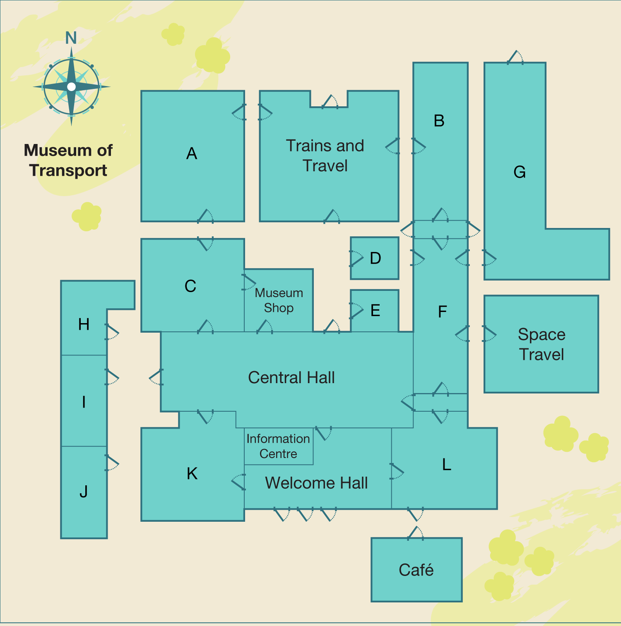

In IELTS Listening Section 2, you will hear just **one** speaker giving information on a topic connected to everyday life.

For example, you may hear some instructions on how to use a machine safely, or some information about different parts of a building and what activities you can do in those places.

When you have a map, the first thing to do is ***orientate yourself.*** This means you have to listen carefully to understand which part of the map the speaker is talking about at the beginning of the recording. The speaker may be giving information to people who are ready in the location on the map, or they may be talking to people who are going to visit location in the future.

**Speaker 1**

1. Starting point? ______________

2. Time of visit? ______________

**Speaker 2**

3. Starting point? ______________

4. Time of visit? ______________

**Speaker 3**

5. Starting point? ______________

6. Time of visit? ______________

**Exercise 6: For the IELTS map labelling task, it is a good idea to learn words and phrases for giving directions and instructions. *(Track 4.6)***

**Read and listen to the tour guide giving directions to three locations. Complete the directions with the correct word or phrase you hear.**

|  |
| --- |
| *OK, I’m going to tell you where some of the important rooms in the museum are. We’ll start with the ‘Car Collection’ room. So we’re here in the Welcome Hall, (1)_______________ the Central Hall. You need to go through the door over there on the right. That’ll take you to the room that (2)________________ to the café, but don’t go that way – take the other door instead. Go across the corridor and then you’ll enter a long, (3)_________________ room. Walk all the way through this room, through the corridor and into the next one. That’s where you’ll find our collection of cars.*  *Alright, you’ll also be visiting the exhibition called ‘Going Second Class’. Let me explain how to find it. From here, the Welcome Hall, go (4)_____________ into the Central Hall, and then head for the door on the left on the (5)_______________ side of the hall. Go through the door that leads outside – and then you’ll see a row of three buildings. When you’re facing the buildings, the middle building will be directly (6) ________________ you, and you want the one on the left of it.*  *Alright, what about the ‘Fashion and Travel’ room? There are a couple of ways to get there, but I suggest you leave here, the Welcome Hall, and go into the Central Hall. (7)_________________ left, but don’t go all the way to the end. You want the door on your right, as you’re facing the western exit. That’ll (8) _________________ the ‘Fashion and Travel’ room.* |

**Exercise 7: Listen to the tour guide. Choose the correct letters (A–L) from the map for each of the three rooms *(Track 4.7)***

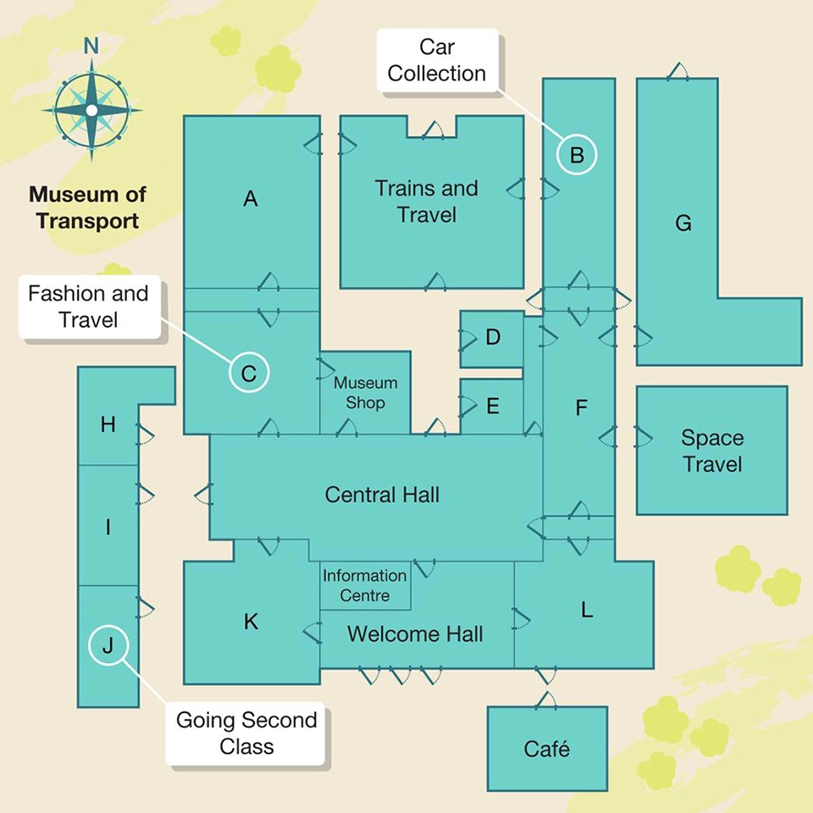

|  |  |  |  |  |  |  |  |  |  |  |  |  |
| --- | --- | --- | --- | --- | --- | --- | --- | --- | --- | --- | --- | --- |
|  | **A** | **B** | **C** | **D** | **E** | **F** | **G** | **H** | **I** | **J** | **K** | **L** |
| Crossing New Horizons building | **○** | **○** | **○** | **○** | **○** | **○** | **○** | **○** | **○** | **○** | **○** | **○** |
| Map room | **○** | **○** | **○** | **○** | **○** | **○** | **○** | **○** | **○** | **○** | **○** | **○** |
| Explorers room | **○** | **○** | **○** | **○** | **○** | **○** | **○** | **○** | **○** | **○** | **○** | **○** |

**Exercise 8: Listen and answer questions 1-4 *(Track 4.8)***

*What helped each person to become successful?*

Choose **FOUR** answers from the box and write the correct letter, A-F, next to Questions 1-4.

1. the film maker
2. the ballet dancer
3. the scientist
4. the chef

|  |
| --- |
| **Reasons for success** A. a personal style D. an invention  B. a lot of money E. a wise decision  C. a relative’s influence F. a change of job |

**Exercise 9: Listen and write the correct letter (A-G),**

**next to these questions (1-3) *(Track 4.9)***

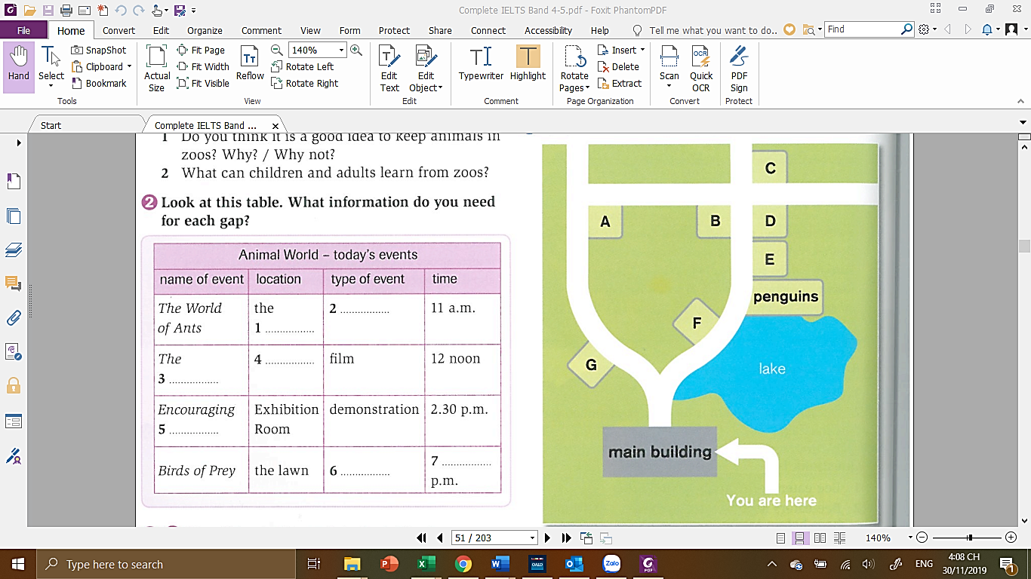

gift shop

restaurant

picnic area

**LISTENING SCRIPT**

**Exercise 1. Track 4.1**

**Announcer:** You will hear two students, John and Denise, talking about a future trip to a Museum of Transport.

**John:** Hi, Denise. Are you looking forward to our field trip to the Museum of Transport tomorrow?

**Denise:** Yes, absolutely. I haven’t been there for ages.

**John:** Well, I think they’ve added some new buildings in the last few years, and they’ve increased the number of exhibitions. Like, there’s a new section on space travel.

**Denise:** Great. That’ll be interesting, I expect. Now, what activity did our tutor say we had to complete when we arrived at the Information Centre at the museum?

**John:** Well, we’ve already got our timetables for the whole visit, so we don’t need to pick those up.

**Denise:** Oh, I remember – we’re supposed to introduce ourselves to someone from the museum – the person who’s going to show us around the museum later on and talk to us about some of the exhibits.

**John:** You’re right. That’s it. OK, well, we’d better do that first. Oh, and I saw on the website that they’ve got a great room full of maps, too. I’d like to see that if we have time.

**Denise:** OK, so what other …?

**Exercise 3. Track 4.3**

**John:** … to see that if we have time.

**Denise:** OK, so what other activities do we have to complete?

**John:** Well, we have to visit the Space Travel building, right?

**Denise:** Yes, I’m looking forward to seeing some of the engine designs. I saw a great documentary on TV recently about how engine design has really progressed over the last 30 years and it really got me interested.

**John:** Hm, OK, that sounds cool. Anyway, I think that what we have to do is pick up a worksheet from the tour guide and answer a lot of questions about the different engines and the space missions they were used for.

**Denise:** Yes, so there’ll be quite a bit of information we need to look for in that building. We’ll have to allow ourselves enough time to read it all.

**John:** OK, maybe we should do that first, then.

**Exercise 4. Track 4.4**

**Denise:** … need to look at in that building. We’ll have to allow ourselves enough time to read it all.

**John:** OK, maybe we should do that first, then.

**Denise:** And then there’s the Trains and Travel room.

**John:** Yes, what do we need to do there?

**Denise:** Well, I think that on a Tuesday – that’s the day we’re going – some people who used to work as engineers for the railway line come and spend a few hours at the museum talking to people. So I think the idea is that we prepare a list of questions for them and talk to them and find out about their lives and the job they used to do.

**John:** That’s great. Do you think we'll be allowed to film them? The engineers, I mean? I could record them on my phone and we could listen to it later – maybe even play it back to the class!

**Denise:** That's a good idea, but I don't know if we can do that. I'll email the museum later and try to find out.

**John:** Would you? That’d be great, Denise, thanks. I’m sure we’ll hear some pretty interesting stories about ‘the old days’ from them.

**Denise:** Yes, and how things have changed. Now, what about the Central Hall. What’s the activity there?

**John:** Let me see. I made some notes when the tutor was talking to us about it. OK, here it is. There’s a large screen somewhere in the hall that the museum’s got to show a short documentary about the way the city started off in the 19th century – how it was built by the first people who came to live here.

**Denise:** OK, great. Let’s make sure we watch that when there’s not too many people around – I want to make sure I can hear it properly.

**John:** Alright. And there’s another location that the tutor said was part of the tour. The ‘Going Second Class’ room.

**Denise:** What can we see in that room?

**John:** Well, I had a look on the website. It’s part of an exhibition about travelling by ship – when people went on really long voyages and they were at sea for weeks, sometimes even months.

**Denise:** So I suppose that ‘Going Second Class’ is about the people who bought the cheaper tickets?

**John:** That’s right. If you were rich, you could have a nice room all to yourself on the ship. But for many passengers, they all slept in the same space full of lots of beds.

**Denise:** And lots of noise!

**John:** So, in the ‘Going Second Class’ room, I think they’ve made it look exactly like the area where those people had to sleep – and there’s a lot of headphones in there, and you can use them to listen to people talking about their memories of travelling like this.

**Denise:** I guess we should take some notes, then. We might be able to use them for our assignment next week.

**John:** Good idea. OK, is there anything else …?

**Exercise 5. Track 4.5**

**Announcer:** Speaker one  
**Speaker 1 (Tour guide):** OK, to get from here, the Welcome Hall, to the Space Travel building, take the door on the right. When you get into the next room, you’ll see it has two doors – you want the one on your left. Go through there, and through the corridor into the long, narrow room opposite, and then take the first door on your right. And you’ll see that you’re outside the Space Travel building.  
  
**Announcer:** Speaker two  
**Speaker 2:** … so I hope you're all feeling better now after the tea and cake – I know I am! OK, then let’s see. For those of you who want to see the Space Travel building first, it’s very easy. When you go out of here, you’ll see the Welcome Hall on your left. Don’t go that way, just turn right – towards the gardens – and then left and there it is – the Space Travel building will be right in front of you.  
  
**Announcer:** Speaker three  
**Speaker 3:** … OK, so the bus will get us to the Museum of Transport for about ten o’clock in the morning and we’re going to be arriving at the back car park. So that means we’re going to go to the Museum Shop first. If you want to see the new exhibition in the Space Travel building, you’ll have to go out of the shop and into the Central Hall first, and then go through the door that is immediately on your left. You’ll see two small rooms on your right and the Trains and Travel room in front of you. Turn right outside the Trains and Travel room and go through the narrow corridor in front of you – that’s the one that goes between the two long rooms – and then you’re outside. Then turn right and walk past the L-shaped building until you get to the Space Travel building.

**Exercise 7. Track 4.7**

**Tour guide:**  
The building called ‘Crossing New Horizons’ contains many types of boat from different countries. What you need to do is walk straight ahead from the Welcome Hall into the Central Hall. From there, you want to head out of the exit that you can see in the right corner of the north wall. That’ll take you into a long, narrow corridor with two small rooms on the left-hand side. Opposite those is a door that leads into a long room. Walk straight across to the door on the far side and that leads out to the ‘New Horizons’ building. It’s an L-shaped building. You can’t miss it.

Now, we have a new exhibition of some very old maps. It’s really worth a look. So to get to the Map room, the easiest route would be to leave the Welcome Hall and go through the Central Hall. You’ll see the Museum Shop on your left, and a couple of small rooms on your right. It’s the little room that’s nearest to ‘Trains and Travel’ that you want for the maps.

The room called ‘Explorers’ is definitely somewhere you should spend some time in. From here, the Welcome Hall, go through into the Central Hall and then walk towards the door furthest to the left on the north wall. Go through that door and walk all the way to the door on the other side – you pass the Museum Shop on your right as you go through. Just walk across the corridor and you'll see the sign for ‘Explorers’ room right over the door. Not only does it contain some fascinating information about the men and women who first explored this country, but it also has a great view of the park. OK, does anyone …

**Exercise 8. Track 4.8**

**Man** So we have to do a presentation on a successful person at our next seminar.

**Woman** Yes, do you have any ideas?

**M**  Well, I’ve been on the Internet and picked out a couple.

**W** Ok – I’ve got some suggestions, too.

**M** Right, well, you start.

**W**  Ok … um, his name’s Mahmoud Kaboor and he’s a film maker in Dubai in the United Arab Emirates.

**M** Sounds good.

**W** Yes. He’s the managing director of a very big film company.

**M** So what made him successful?

**W** Apparently his uncle was a film student and because of that, he started making short films when he was only 16.

**M** That’s quite young … and were they good?

**W** Yup. He won a scholarship to go to Canada and study film, and that’s how his career developed.

**M** Great. Um … here’s one of my suggestions. She was a ballet dancer – born in St Petersburg in Russia in 1881.

**W** Anna Pavlova. Ok – why have you picked her?

**M** Well, firstly, because her parents weren’t wealthy – they were very poor, in fact – and yet she still went to the School of Imperial Ballet at ten years of age.

**W** What’s so young! Was she very talented?

**M** Yes, she was, but she didn’t follow the rules of ballet. She was very individual and did things that were different from other ballerinas at the time.

**W** Ah – and that’s what made her stand out …

**M** Yes.

**W** Ok. I’ve got another woman – Marie Curie.

**M** She’s very famous. Wasn’t she Polish?

**W** Yeah, born in 1867, but did you know that she was the first woman professor at the University of Paris and the first woman to win a Nobel prize?

**M** Yes – amazing!

**W** There were many brilliant scientists around when she was working.

**M** So why did she do better?

**W** Other scientists couldn’t get ahead of her because she sensibly published her ideas straight away.

**M** What a clever thing to do!

**W** Yeah – everyone dose it automatically these days, but all those years ago, people often didn’t think about it.

**M** Great! Well, here’s one more.

**W** Ok – who is it?

**M** This is an African – American guy who worked as a chef in the 1850s. His name was George Crum.

**W** Did he make a famous dish or something?

**M** Not exactly – but without him, we wouldn’t have the potato chip. Or crisps, as the British call them.

**W** Oh!

**M** Yeah. Apparently, he had a customer who was annoyed because his French fries were too fat and soft. So he sliced a new potato as thinly as he could and fried it until it was hard and crunchy Added lots of salt …

**W** …and a new snack was created.

**M** Well, I, I think we’ve got some interesting people here …

**Exercise 9. Track 4.9**

Now, I’ll just give you a few directions before you leave, especially for those of you who are feeling a bit hungry. When you leave the main building, you come to an area where the path divides. If you take the right-hand path, you’ll see the lake on your right, and exactly opposite the lake on your left is the gift shop. Apart from selling gift, it sells snacks, sandwiches and light drinks. If you walk on past the lake, on your right you’ll also see the penguins. Go past the penguins and you’ll come to the restaurant, also on your right. Don’t go too far, or you’ll come to the aquarium. The aquarium is on your right at the crossroad, and just over the crossroad, also on your right, is the lion enclosure.

If you’re thinking of having a picnic, the best place to go is the picnic area, and for this you need to turn left at the crossroad and walk along a few meters. At the end of the path, you’ll find the picnic area on your left.

Now, if you have any questions, I’d be happy to answer them and, once again, I really hope you enjoy your visit. Thank you.